EXPERIMENT 2
2.Create a simple cloud software application for Property Buying & Rental process (In Chennai city) using any Cloud Service Provider to demonstrate SaaS

Aim
To develop a simple cloud-based software application for managing the Property Buying and Rental Process in Chennai City using Zoho Creator as a Cloud Service Provider and to demonstrate the Software as a Service (SaaS) model.

Procedure
- Log in to Zoho Creator.
- create a new cloud application named Property Buying and Rental System.
- Create a single form named Property Details and add the required customer, property, transaction, and payment fields.
- Configure suitable field types such as Name, Phone, Email, Number, Currency, Date, and Drop Down with options for buying and renting properties.
- Create a simple workflow to validate the customer details and manage the property booking process.
- Enter sample property records from different locations in Chennai and verify the submitted information using the cloud application.
- Save and publish the application.
- Test the application by entering sample booking details and verify that the records are stored correctly.

Implementation
The Property Buying and Rental System was implemented using Zoho Creator as the cloud service provider. A single form named Property Details was created with customer, property, location, price, rental, payment, and booking fields. Options for Buy/Rent, property type, and booking status were added using drop-down fields. A simple workflow was created to validate customer details. Sample properties from Chennai locations were entered and tested. The submitted records were stored and managed through the cloud application.

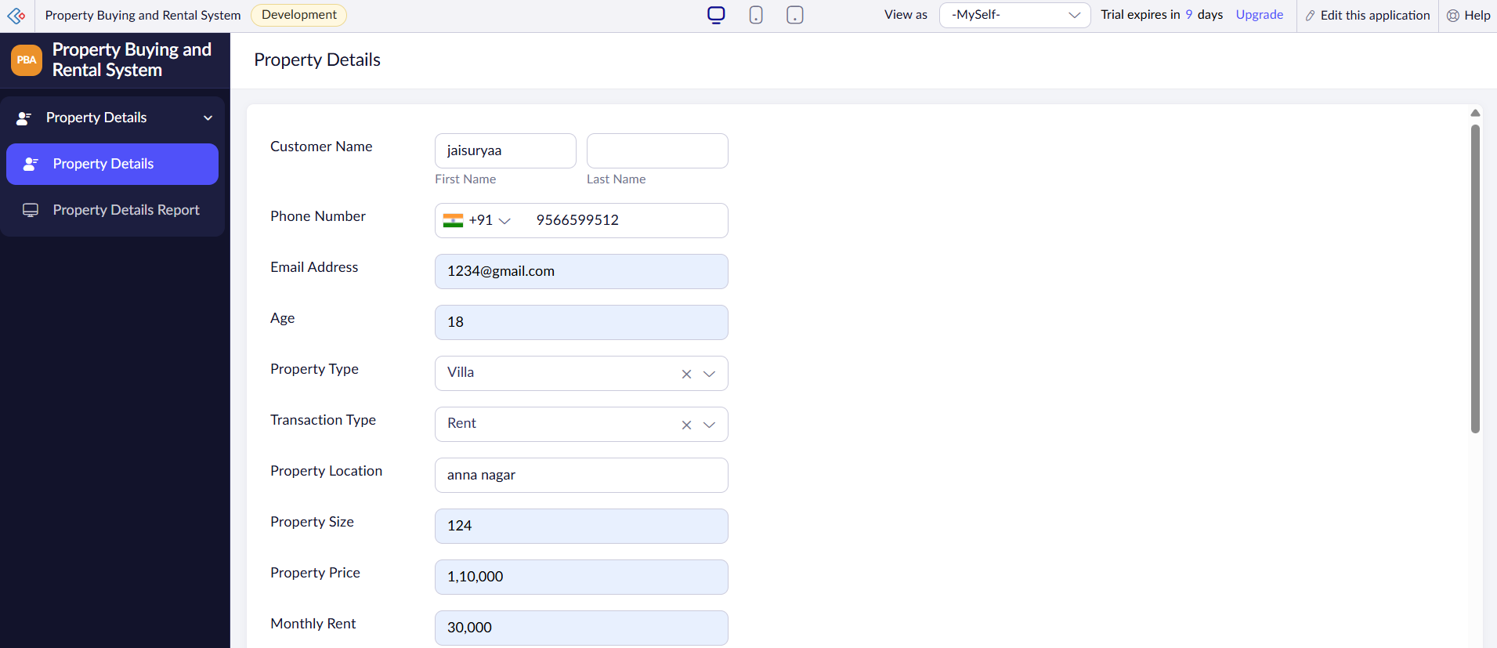

FIGURE 1: PROPERTY BUYING AND RENTAL SYSTEM FORM

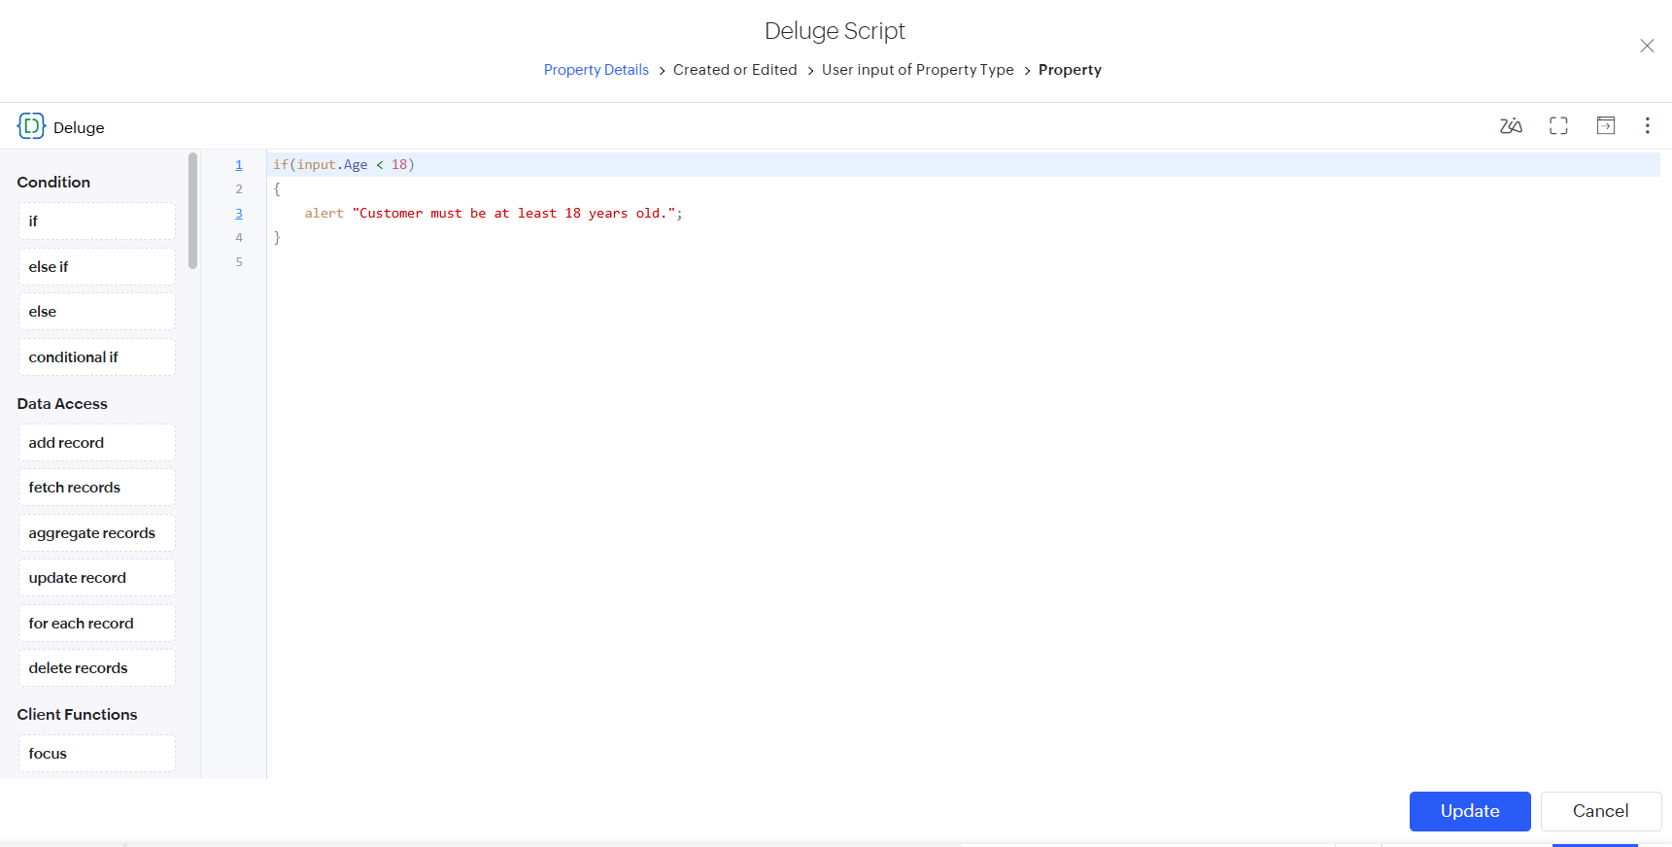
FIGURE 2: WORKFLOW

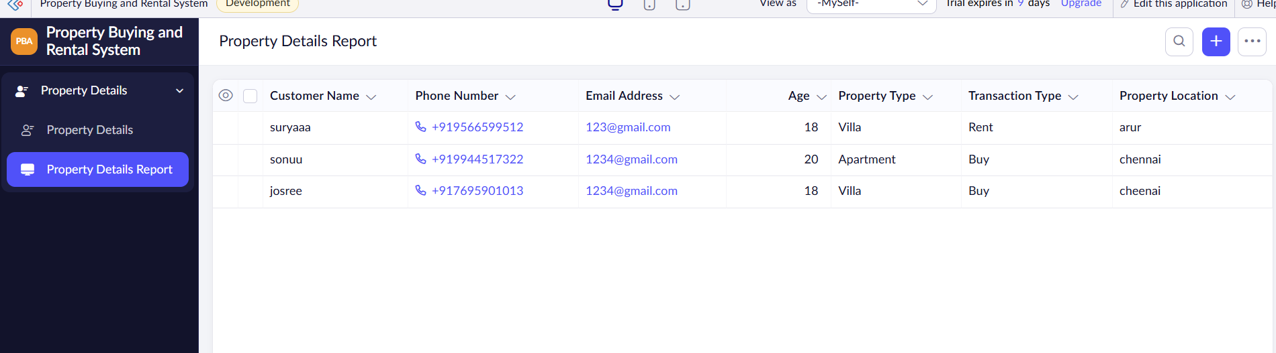
FIGURE 3: PROPERTY BUYING AND RENTAL SYSTEM REPORT

Result
Thus, the Property Buying and Rental System was successfully developed using Zoho Creator. The application allows users to enter and manage customer and property details, select buying or rental options, record payment information, and manage booking status. The experiment successfully demonstrated the use of Software as a Service (SaaS) through a cloud-based application.

